Date :23/1/2026
12. Demonstrate virtualization by Installing Type-2 Hypervisor in your device, create and configure VM image with a Host Operating system (Either Windows/Linux), using VMware workstation.

AIM
To install a Type-2 Hypervisor (VMware Workstation), create and configure a Virtual Machine with Windows 11 operating system, and verify successful virtualization.

SOFTWARE REQUIREMENTS
- Host OS: Windows 10 / Windows 11
- Hypervisor: VMware Workstation
- Guest OS ISO: Windows 11 (64-bit)

PROCEDURE
- Open VMware Workstation on the system.
- Click on Create a New Virtual Machine.
- Select Typical (Recommended) and click Next.
- Choose Installer Disc Image File (ISO) and browse the Windows 11 ISO file.
- Click Next and select:
  - Guest OS: Microsoft Windows
  - Version: Windows 11 x64
- Enter a Virtual Machine Name and select the location to store the VM.
- Allocate Disk Size = 20 GB and select Store virtual disk as a single file.
- Click Customize Hardware:
  - Memory: 4 GB
  - Processor: 2 cores
  - Network Adapter: NAT
  - Enable TPM (Trusted Platform Module)
- Click Finish to create the virtual machine.
- Click Power On This Virtual Machine.
- The system displays the EFI Boot Manager screen.
- Select Boot Normally or EFI VMware Virtual NVMe.
- Windows 11 setup starts, confirming successful virtualization.

Output
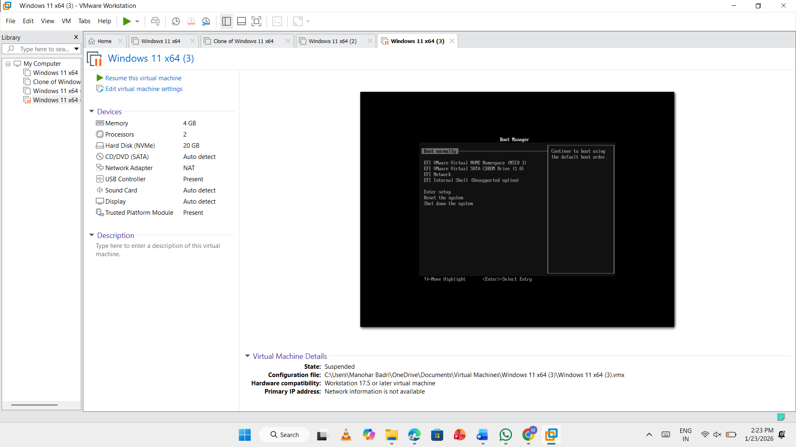

RESULT
The Virtual Machine was successfully created and executed using VMware Workstation (Type-2 Hypervisor) and the Windows 11 OS booted correctly.

